Example for behaviour
Workflow: Only for demonstrating the behaviour
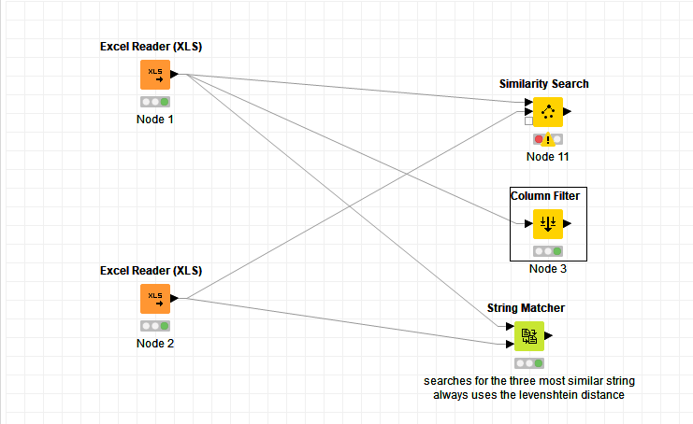

Similarity Search: „Configure…“ : Shows no input columns
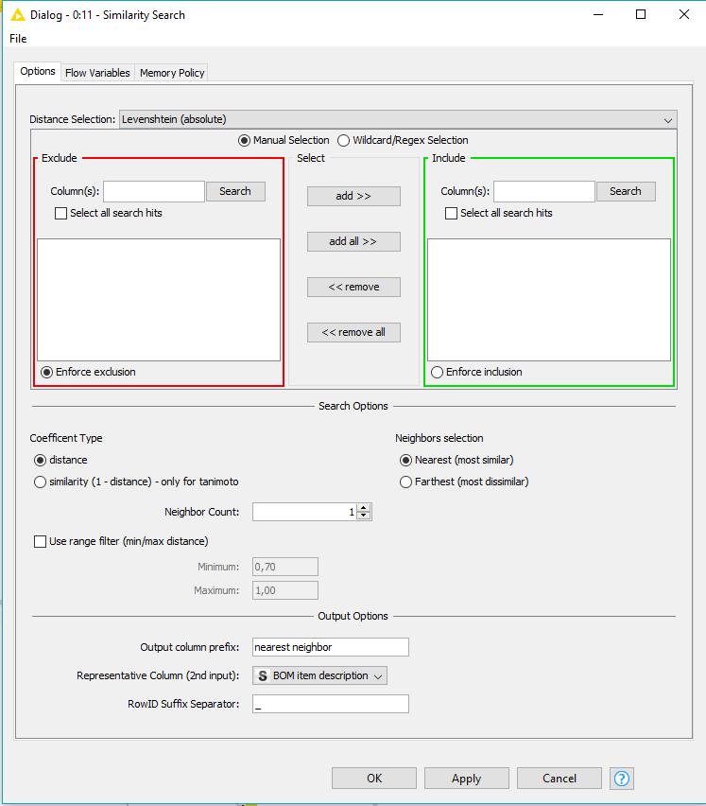
Column Filter: „Configure…“ : Shows input columns
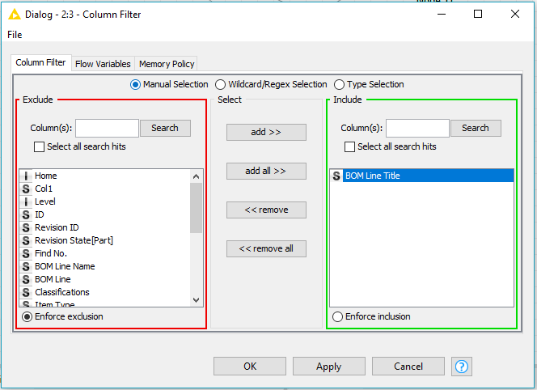

String Matcher: „Configure…“ : Shows input columns
